**Use Cases:**

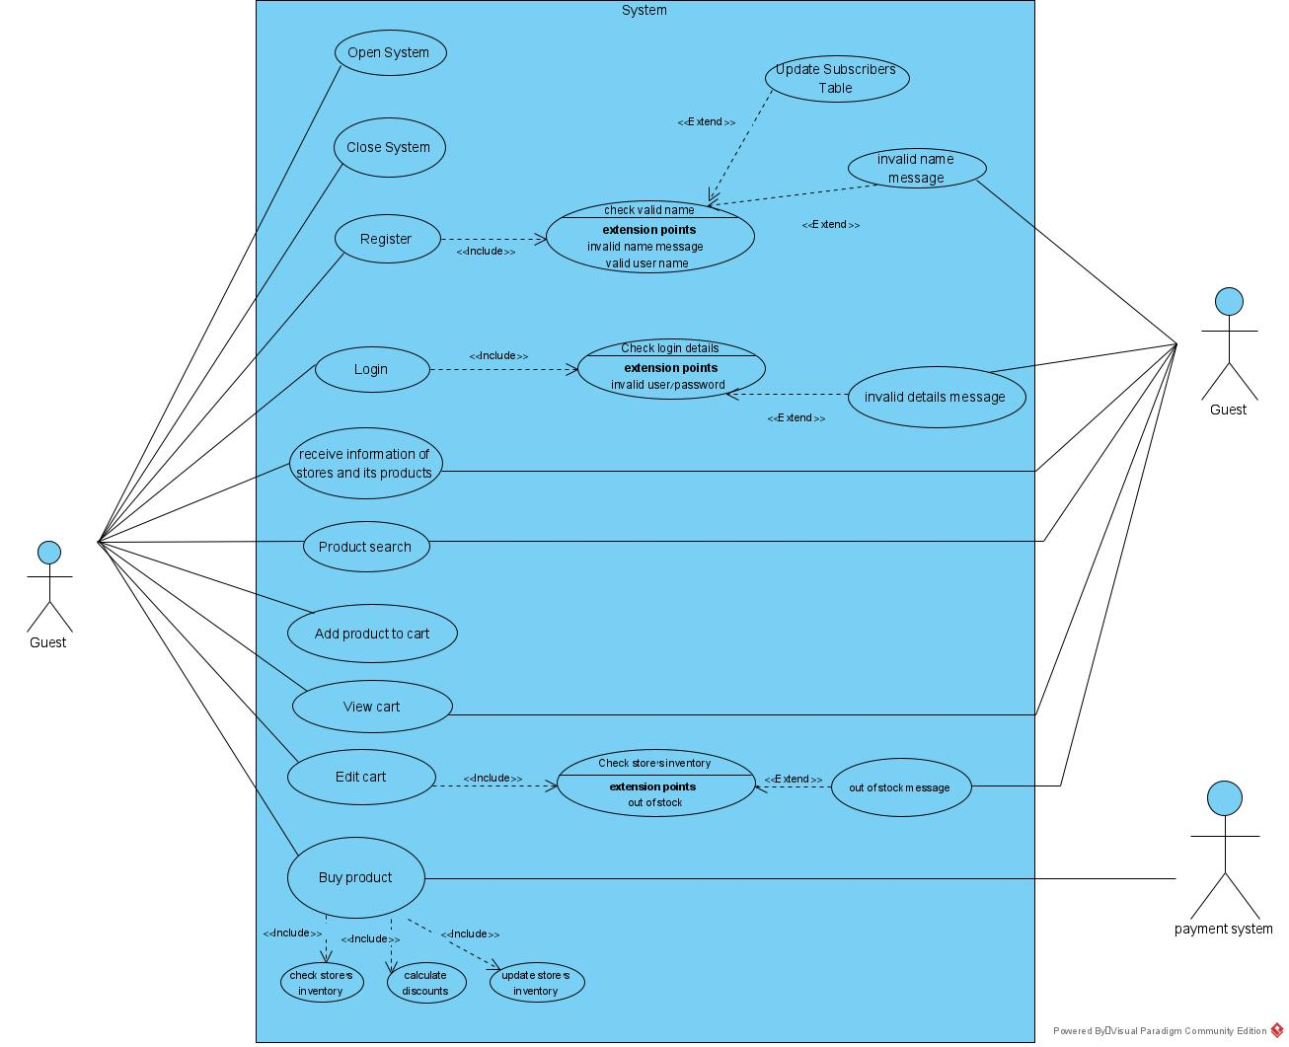**2- Guest Buyer**

**2.1: Enter the trading system  
Actor:** Any User  
**Precondition:** User is offline  
**Post condition:** User is onlineas a guest. **Parameters:** none **Actions:**

1. User enters the system
2. The System checks for the existence of at least one system manager.
3. The system is initiated and the user is recognized as guest

**2.2: Exit the trading system  
Actor:** Any User  
**Precondition:** Guest User is online **Post Condition:** Guest User is offline **Parameters:** none **Actions:**

1. Guest user exits the system

**2.3 : Register to the trading system**  
**Actor**: Guest User  
**Precondition**: username is not already used  
**Post Condition**: username and password were added to the users table  
**Parameters**: username , password  
**Actions**:

1. Guest user chooses to register and enters his username and password
2. The system checks the username is not already used
3. The system checks for the username and password validity
4. If all details are valid a new user is created and saved in the system tables
5. Otherwise the process fails

**2.4: Login to the trading system  
Actor:** Guest user  
**Precondition:** no logged on user in current session, user is already registered **Post Condition:** User is logged onas Subscriber **Parameters:** username and password **Actions:**

1. Guest user enters his username and password
2. The system checks for a match between the username and password
3. If the username and password matches the guest user changes his state to logged on
4. Otherwise the process fails

**2.5: View a store and its products.  
Actor:** Any User  
**Precondition:** The store exists in the system **Post Condition:** none **Parameters:** The store **Actions:**

1. The guest user chooses a store
2. The system returns all details about the store and the products in the store

**2.6: Search for products which can be filtered by some parameters.  
Actor:** Any User  
**Precondition:** none **Post Condition:** only data filtered by the parameters is presented **Parameters:** one or more of: product name, category and keywords**.**optional : any number of product's attributes such as: price range, ranking , etc. **Actions:**

1. Guest user asks to see details about products according to one of the following: product name, category and keywords
2. The trading system searches all stores and return only products that correspond to the parameters given.
3. If optional parameters are given the system filters the results from the previous stage according to these parameters.
4. The filtered data is returned

**2.7: Add products from a store to his shopping cart.  
Actor:** Any User  
**Precondition:** The store's inventory contains all requested products. **Post Condition:** The products has been added to the users old shopping cart. **Parameters:** products and quantities to add. **Actions:**

1. The user asks to add products to his store-cart
2. If the user has no store-cart for this store, a new store-cart is added to his shopping-cart and the products are added to it.
3. Otherwise the products are added to his old shopping cart
4. If the user is a subscriber the store-cart is saved in the system's tables.

**2.8.1: View shopping cart**.  
**Actor**: Any user  
**Precondition**: none  
**Post Condition**: none  
**Parameters**: none  
**Actions**:

1. The user asks to see his shopping-cart
2. The system returns a list of all of his store-carts

**2.8.2 : Edit shopping-cart  
Actor:** Any user  
**Precondition:** none **Post Condition:** the shopping-cart has changed according to the user's request. **Parameters:** list of <product, quantity> to be changed **Actions:**

1. The user views his shopping-cart (use case 2.8.1) and chooses a store-cart to edit
2. The user enters list of products that exists in his store-cart with their new quantities
3. If the user chooses to increase the amount of products in his store-cart, the system checks for the product availability in the store
4. The store-cart is saved in the system's tables

**2.9: Guest User asks to purchase products  
Actor:** Any user  
**Precondition:** The user have at least one none empty store-cart **Post Condition:** The user's store-cart and the store's inventory is updated according to the amount of purchased products **Parameters:** products, amounts and purchase type **Actions:**

1. User asks to buy products from a store
2. The system verifies that all products are in the store's inventory
3. The system calculates discounts in the store according to its buying and discount policies.
4. The system transfers the payment request to the external payment system and waits for its response
5. If the payment has been approved the user's cart and the store's inventory are updated
6. Otherwise the error message sent to the user

Glossary:  
Online User – the active user in the current session, can be logged in user or guest user.  
Store-cart – the user's cart of products from specific store.  
shopping-cart – all of the user's store-carts.

**3- Subscriber Buyer**